Student Planner Web Application
Name: Shivansh Magotra
Reg No: 2BCE2947

Description:
A browser-based student productivity tool that allows users to:
- Plan subjects with exam dates and daily study hours
- Track daily study progress
- Visualize progress through a dashboard

- Home Page:
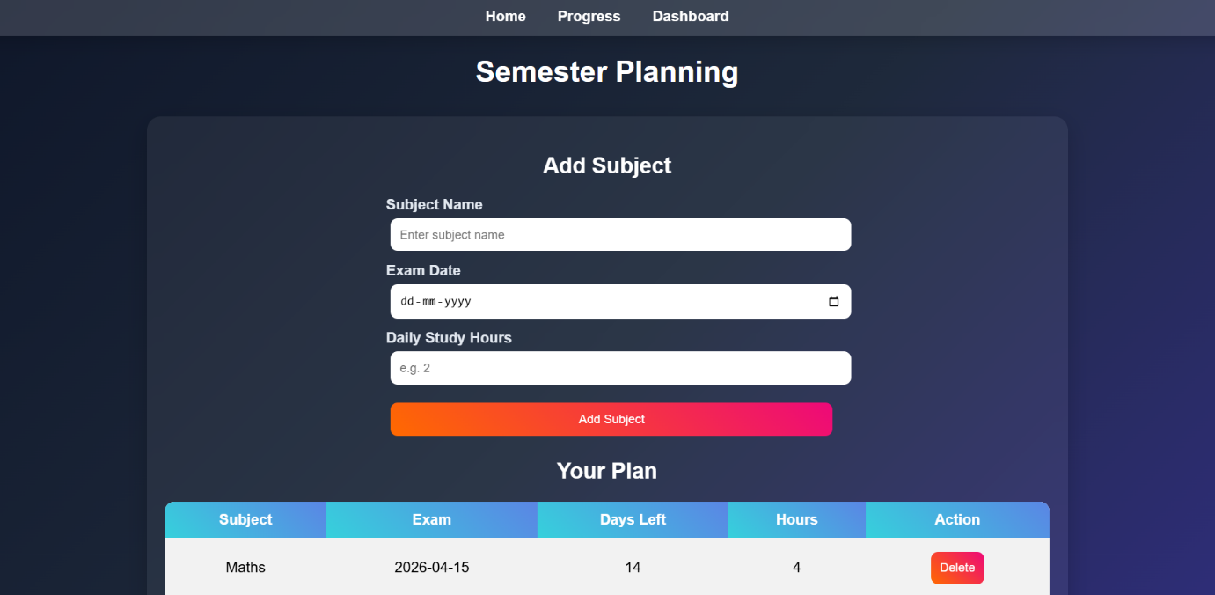
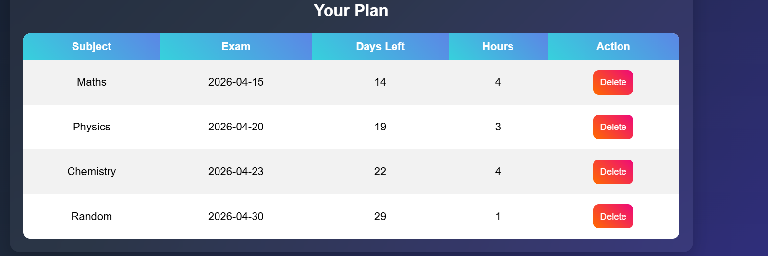
- Adding a navigation bar for accessing different pages:


Code used:
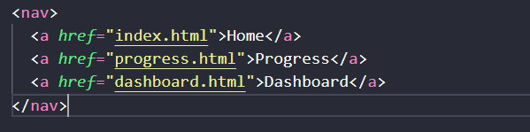
The required files are present in the same folder.

- Adding the subjects for further operations
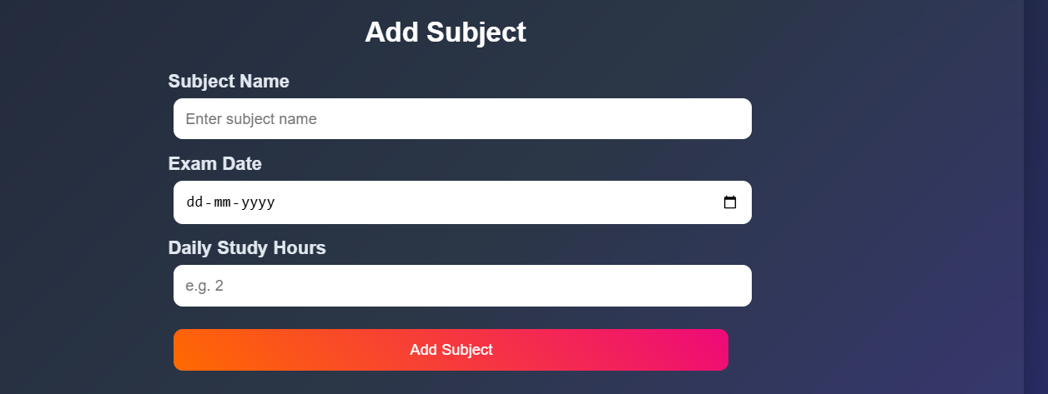
Code used:
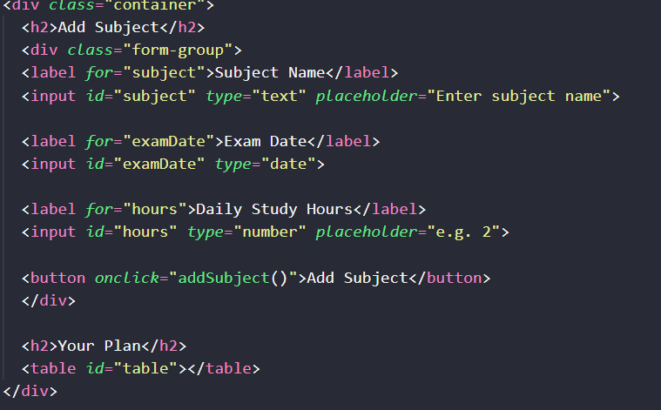
- Changing background colour on hovering

Java Script used:
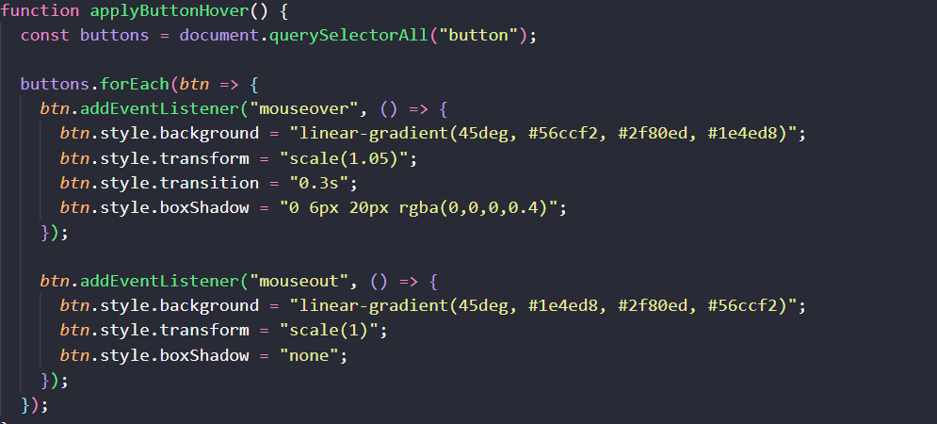
And this function is called after rendering the webpage on every new operation.
This function must be called after rendering, since the DOM only manipulates the current objects but when new subjects are added, there is no event listener for them hence we add this hovering function so that the web page understands to apply hover function on newly created buttons.

- Adding the newly created subjects to the table with subject name, exam date, days left before the exam, number of hours assigned for each subject by the student.
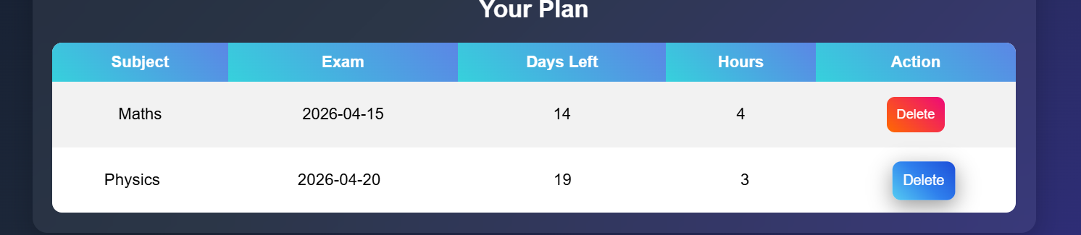
Contains the dynamic buttons for each subject created with hover effects
Code used:
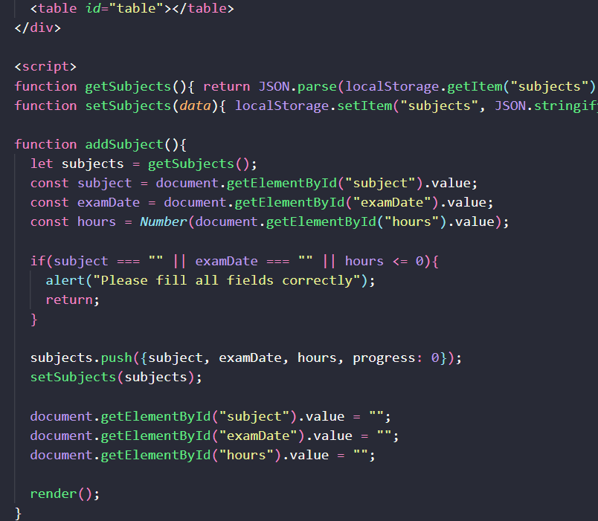
Local storage of the browser is used for manipulating the input. For each subject the table row is appended in the table element in html. It also checks for the invalid input:
- Input Validation:

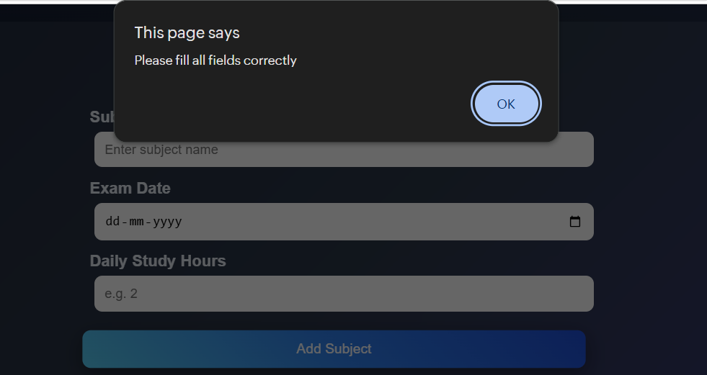

- Deleting a subject:
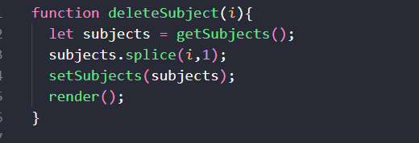
Updating the subjects array using splice function, which uses index ‘i’ which is parsed using for loop used in render function discussed below

- Render Function:
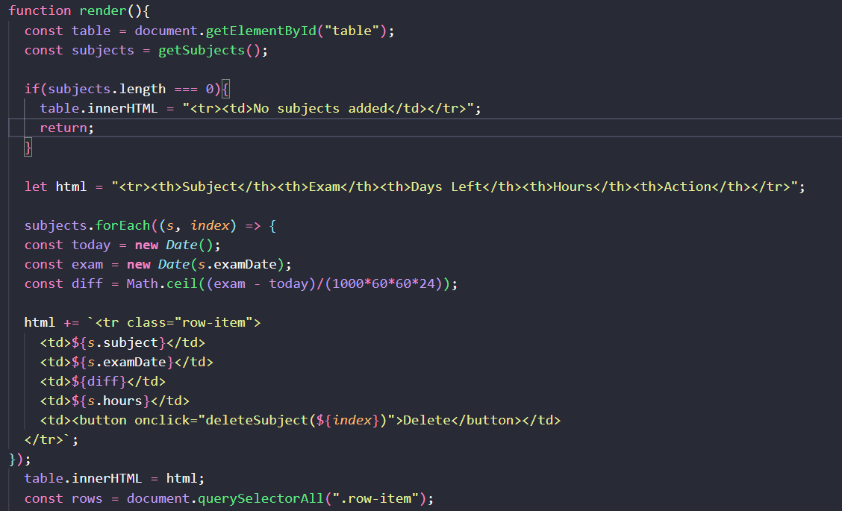
This render function acts as a bridge between the local-storage and the user interface. It takes the subjects info from the local-storage and appends it to the table, and also adds the button to the action column. For this it uses string interpolation using the backticks to add the value of the variable.
- Adding hover effects to the table rows:
Before:
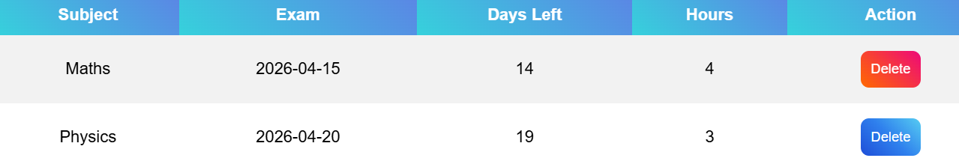
After:
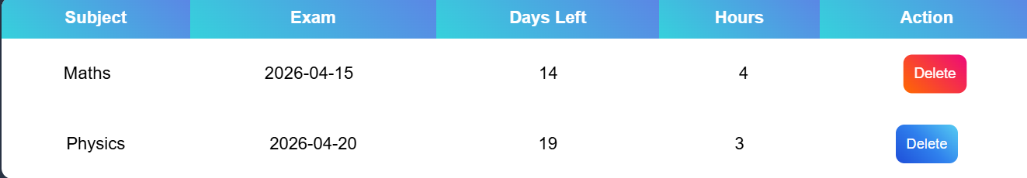
Code used:
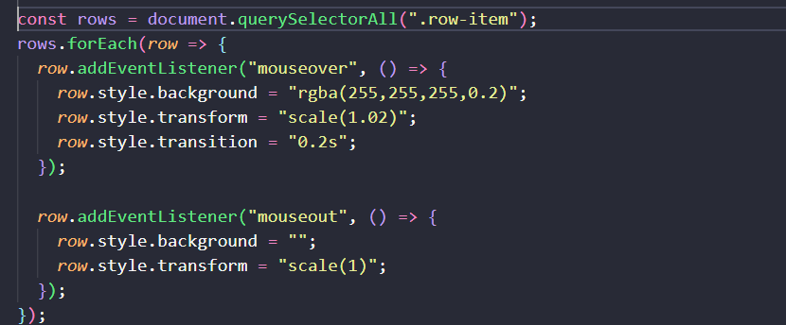

- Progress Page:
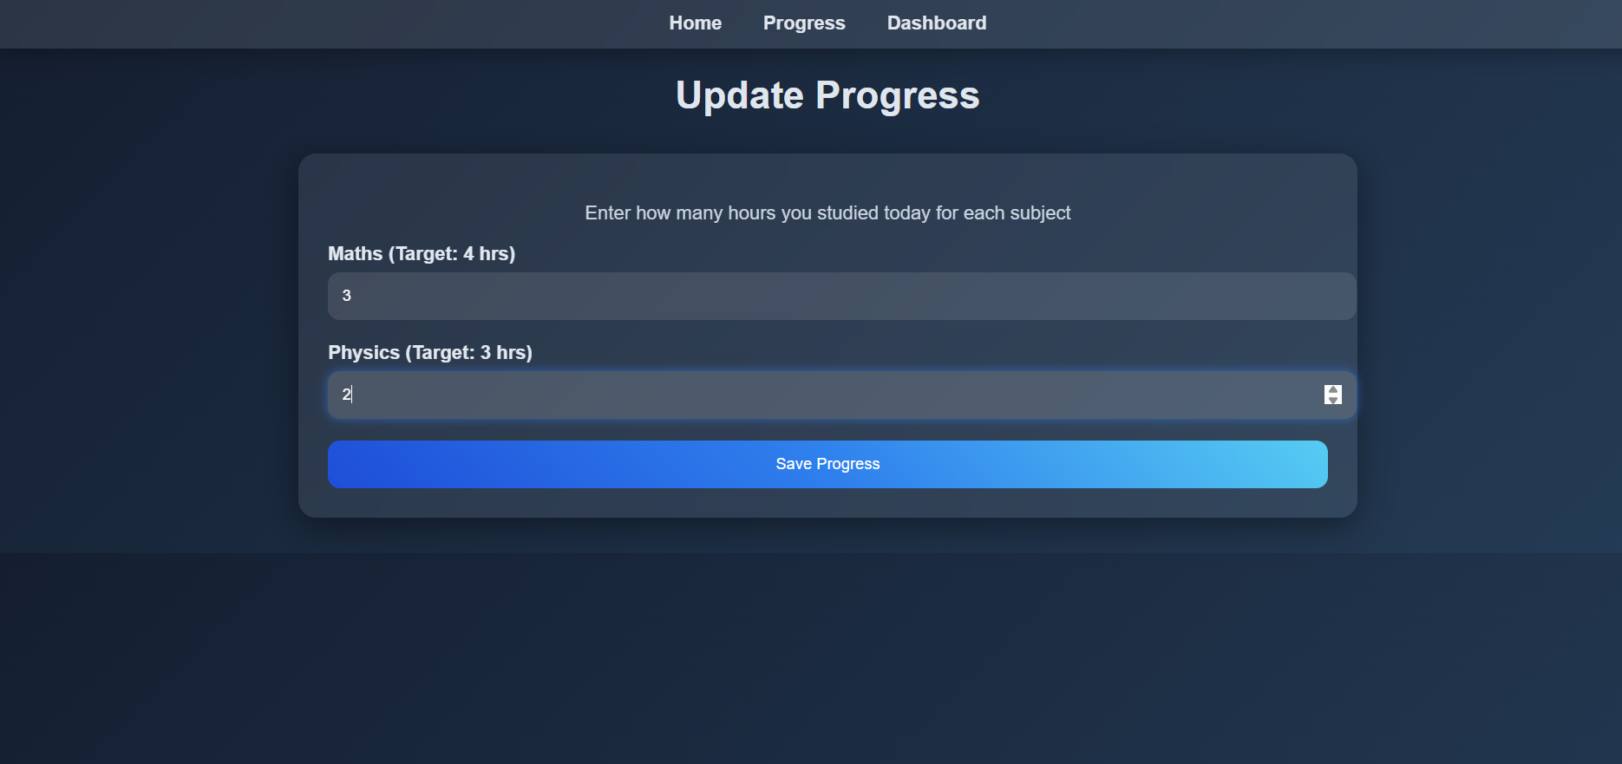
Student needs to add the subject hours for each subject that he did for the day to track his progress
- Takes the information from the local storage and add the details while also asking for the input hours for each subject for the day.
Code used:
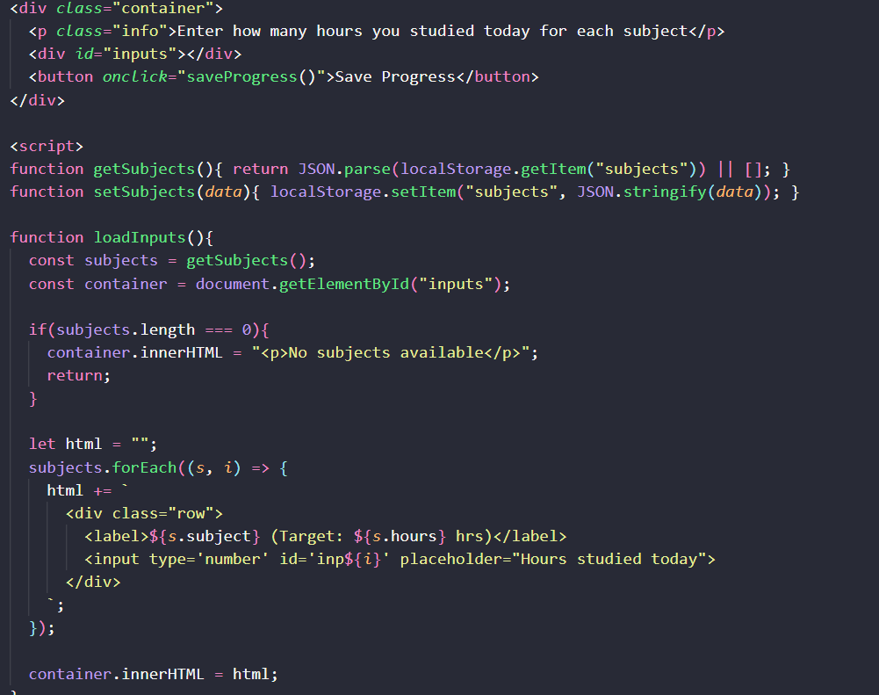
- After getting inputs calculate the progress and share the same using an alert and also saving the progress in the local-storage.
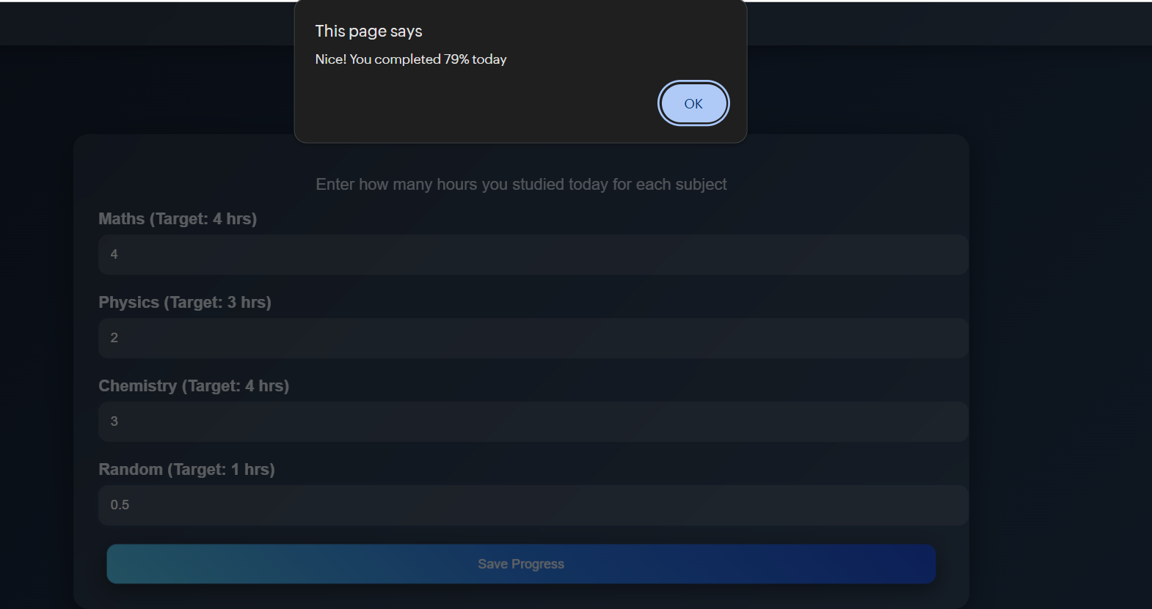
Code used:
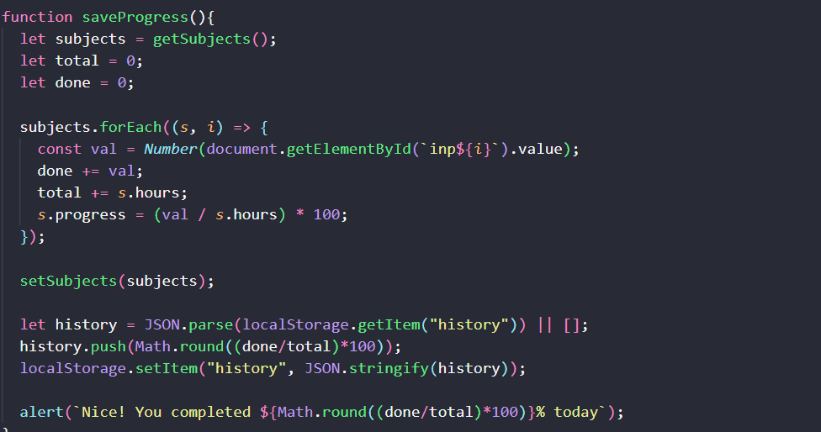

- Applying box-shadow and hover effects on the button:
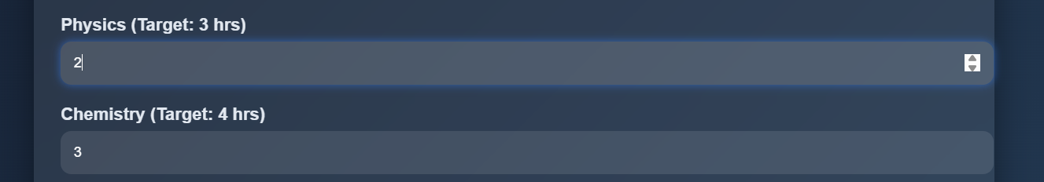
w/o hover:
On hover:
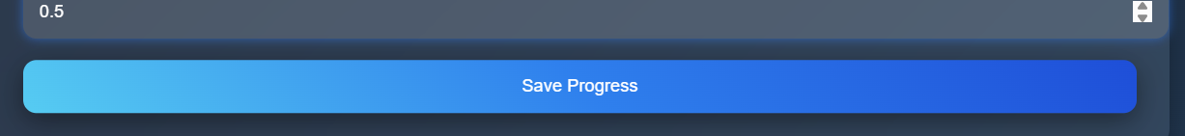
Code used:
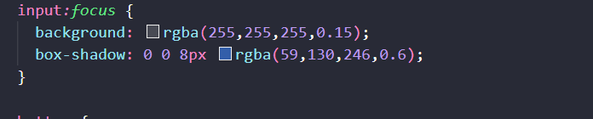
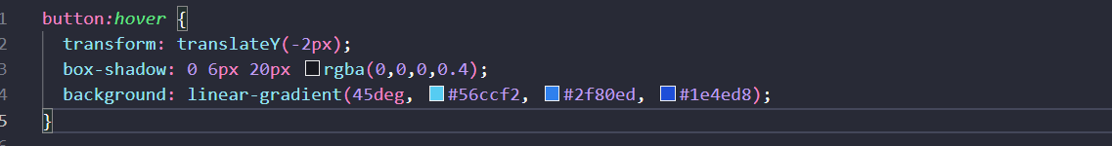
Hover treated by css only without java-script

- Dashboard Page:
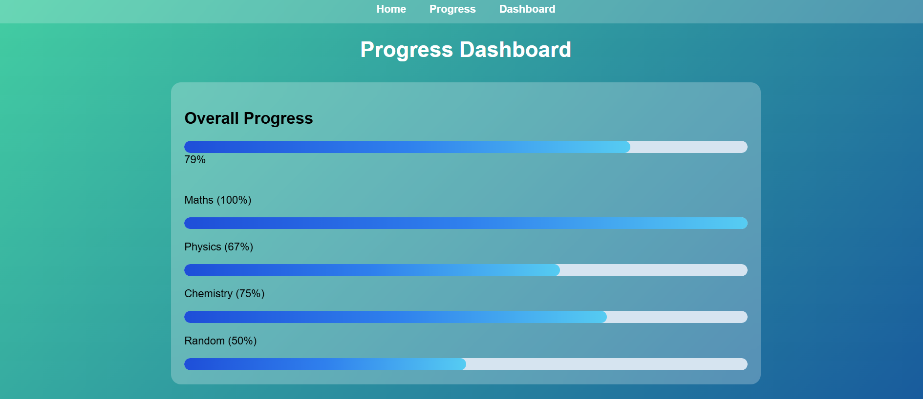
Getting input hours completed from the local storage and label the progress bars with the percent progress value.

Code used:
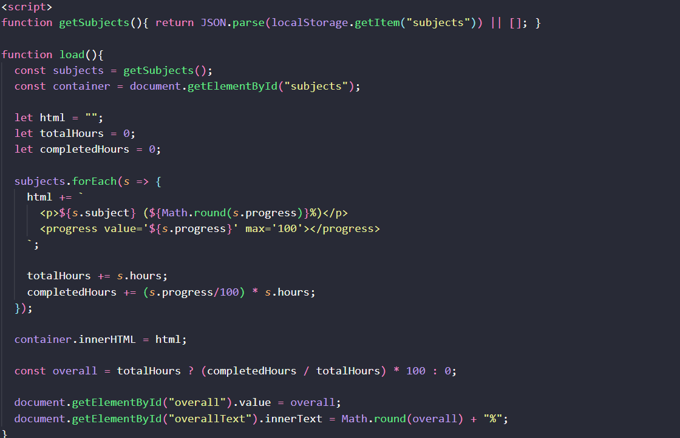
For each subject value or for each row of the table, get the completed hours and for that value calculate the progress and append the “progress” bar in the html.
Also calculate the overall progress which is the average progress of all the subjects and display it at the top labelled as “Overall Progress”.

- Further improvements:
  - Adding authentication system for each user and applying the backend to store the progress for each user.
  - Giving users the option to decide the subjects to study and number of hours for the same for each day of the week.
  - Designing the time-table according to the values provided, viewing each day and the time-slot and the subject name, and applying the progress on the column of the table.
  - Designing a table in which the user can enter the subjects with backlogs and dynamically designing the time slots for the same.
  - Adding a coverage page, in which the user can enter the parts of the subject which he wants to study from a platform and it will also contain a container which will contain the you-tube or the webpage link considering for the same and also adding the check-uncheck feature if it is done.

